Subject: Global Studies I
Benchmark: Parthenon
Standards: 2A, 2B, 2C, 2D

TOPIC: The Glory That Was Greece

MAJOR IDEA: Ancient Greek philosophers, poets, artists, and thinkers extolled the human mind and human capabilities in the arts. This culture of achievement in the arts represents the zenith of human ideals depicted as objects of beauty. These Greeks explored the nature of the universe and the place of humans in the universe. This legacy, described as “the glory that was Greece,” by one poet, remains in great works of literature, sculpture, architecture, and philosophy.

SUGGESTED AIMS:
- What is culture? How do we define works that contribute to culture and those that do not? Are there criteria that determine if a particular work is part of a body of “culture”?
- Greek philosophers, poets, and artists explored themes of beauty, harmony, and order. Using the Parthenon as an example, how does the building express these ideas? Study other works such as The Clouds. How does it express these Greek ideals?
- What are the different Greek orders of architecture? What are their origins? What are their characteristics? Which is the oldest? In which part of Greece did they develop?
- What is logic? What were some of the principles that Greek logical thinkers espoused? How do these ideas differ from notions of ethics and morality? What did Greek logicians hope to discover through their studies and treatises?
- Who were the Sophists? What did they believe? What was the name of the form of debate in which the Sophists engaged?
- Socrates was one of the best-known Sophists. What do we know about Socrates? Which tenets of Socrates are applicable today? Why? What is the Socratic method? Why is it named for Socrates?
- What were the philosophical differences between Plato’s Academy and Aristotle’s Lyceum? How have the notions of these ancient philosophers informed our ideas about contemporary democracy?
- What is the difference between a tragedy and a comedy? Create a Venn diagram showing the characteristics of each and the common elements.
- What is an amphitheater? Why is an amphitheater so acoustically effective? What Ancient Greek theater terms survive in the theater today?
- Why was Greek sculpture and painting revolutionary as compared to the artwork of Ancient Egypt? How did the Greek ideals of beauty and harmony inform these works?

VISUAL EXAMPLES:
- Image of the Parthenon
- Illustration of the Doric, Ionic, and Corinthian architectural orders
- Image of a Greek amphitheater

SUGGESTED ACTIVITIES:
- Stage a performance of a play by Aeschylus, Sophocles, or Euripides. Suggestions include Antigone; the Oresteia; or the comedy Lysistrata.
- Greek vase (amphora) paintings depicted scenes of daily life. Students may illustrate a scene from contemporary daily life and then transfer it to a vase or vessel.
- Re-enact the trial of Socrates. Students may enact the roles of the jurors, the magistrates, and Socrates himself.
- Design a contemporary building that incorporates the ideals of harmony, balance, and beauty that are characteristic of Greek architecture as the Parthenon did.
- Identify all the elements that are part of the Ionic, Doric, and Corinthian orders. (E.g., flutes, arris, cyma recta, etc.)
- Adapt a myth from another culture in the style of a Greek play. E.g., use traditional Greek dramatic elements, such as the chorus, to help convey the action and propel the story.

RESOURCES:
- Perseus Digital Library—Greek Classics. http://www.perseus.tufts.edu/
- Architecture of Ancient Greece. http://harpy.uccs.edu/greek/greek.html
- Classical Drama Sites—includes map of ancient Greek theaters and article about structure of Greek theaters. http://www.webcom.com/shownet/medea/cldram.html

HOMEWORK:
- Write a review of a Greek play (as if it would appear in a newspaper or magazine).
- Greek comedies were vehicles through which playwrights commented on social hypocrisies and issues, much the same way political cartoons do today. Create a political cartoon about a contemporary issue. Create a political cartoon about an issue that confronted Ancient Greeks.
- Have students reflect on the quote from Aristotle on page 118 of World History: Connections to Today. Choose a favorite character from a book, movie, or TV show, and describe how Aristotle’s beliefs apply and help create a character that is nuanced, contradictory, and exceedingly human.
- In what ways did Greek religious practices mirror Greek drama? Consider the procession to the Parthenon every four years. In what ways was this event dramatic? In what ways did the pageantry resemble that of the theater? How were rituals dramatized to be visible and understandable to a large crowd? Ask students to write a short paper on the ways in which their current religious practice missors a dramatic presentation and why.
- What is entasis? How did this visual trick help the Parthenon to appear more perfect when viewed from afar? What is the assumption of the builders with regard to how close to the Parthenon most people would be? Ask students to build a model of a column with entasis and explain how this visual trick works. What is the dramatic effect of such visual “corrections?”
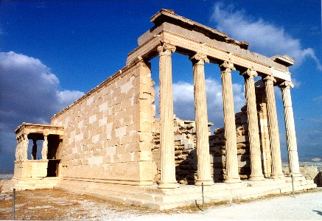
The Parthenon

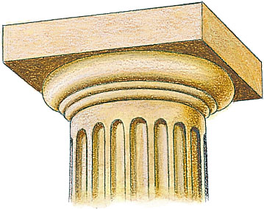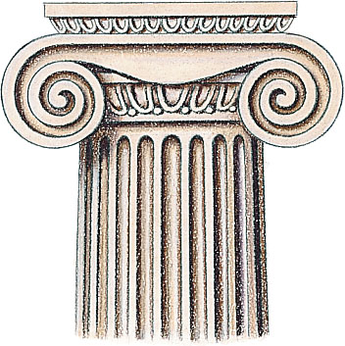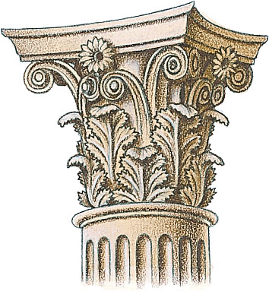
Examples of Doric, Ionic & Corinthian columns

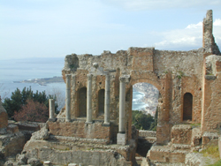
The Greek Amphitheater

